**Classification | Prediction:**

**Problem statement:**

*We do have a E-commerce dataset, we need to identify or predict who are all coming as visitors and converted as out customers.*

*Use the given data, there is a column called “has_converted” as target variable. Do the classification to find whether user will convert as a customer or not.*

**DataSet:** <https://drive.google.com/drive/folders/1ATULlRKrSensZHs2SxaT7y0b68Rc1vQA>

**Steps to follow:**

1. Data read
2. Do Multiple EDA with Plots (Show In streamlit)
3. Preprocessing
4. Stat Analysis
5. Feature Selection
6. Model Building – Build Atleast 3 models.
7. Do predictions for the Live stream Data.
8. Display the 3 model’s precision, recall, accuracy, f1-score

**EDA:**

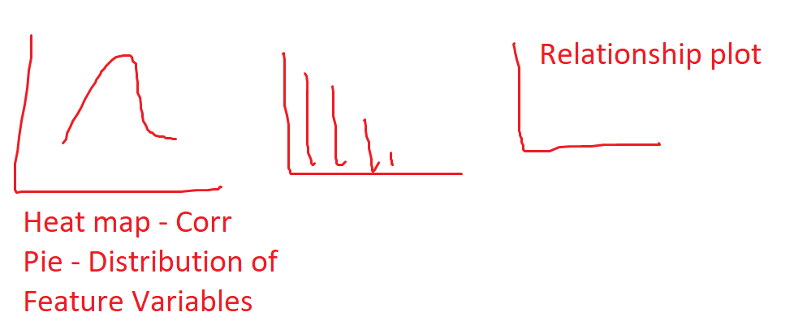

**Model UI**

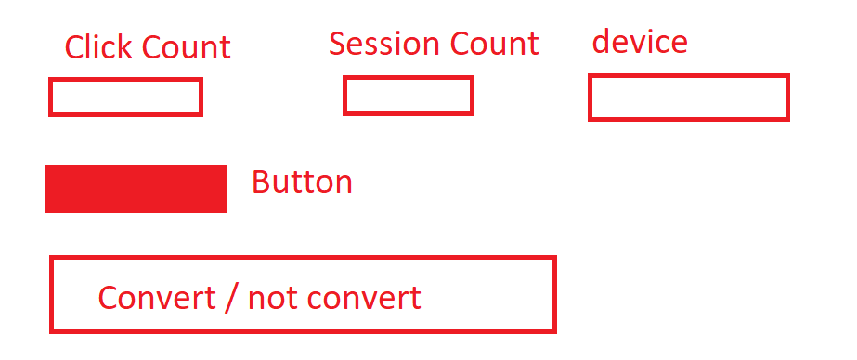

**Image:**

1. Read the Image.
2. Process the Image, and do all possible Image pre-processing steps.
3. Display all the pre-processed images with the Image title. (Ex. Edge Detected Image)
4. If you uploaded the Text Image, show the restlt of OCR. (You can use any ocr like Tesseract, keras-ocr, etc.)

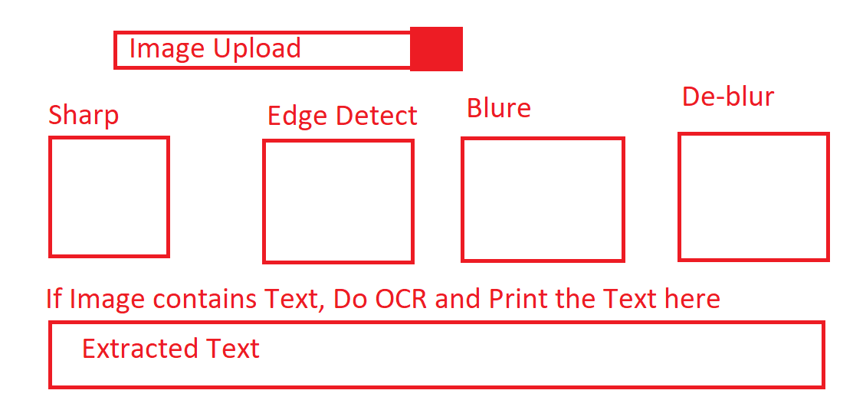

**NLP**

1. Input the bunch of text.
2. Do all the NLP pre-process.
3. Show all steps and its Outputs with its Name.
4. Find the keywords from the text.
5. Do sentiment analysis for the text.

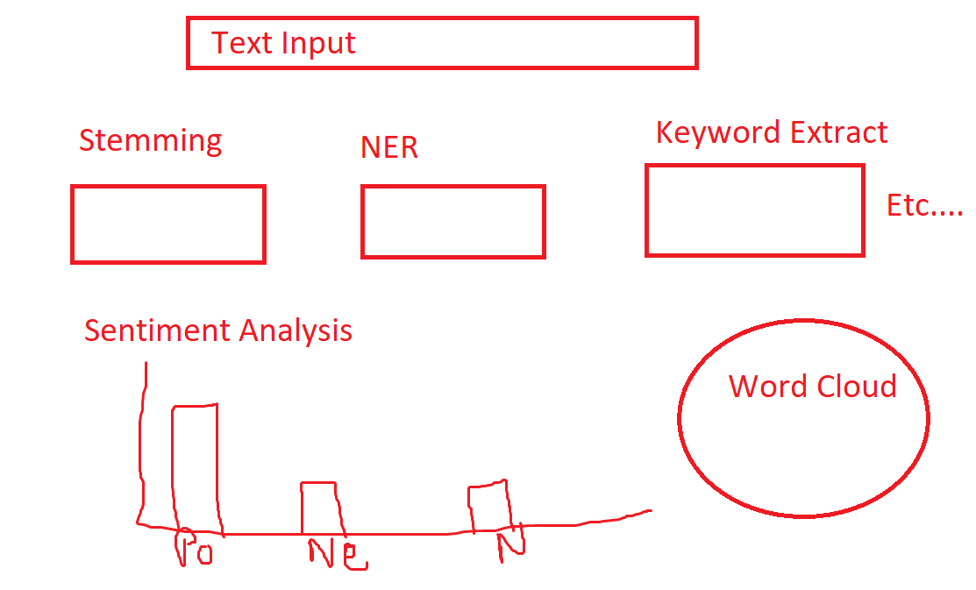

**Recommendation System:**

1. Build a product recommendation with you own dataset.
2. If User entered any product after they clicked “Get Recommendation” Button, your model should show the recommended products. (Recommendation should be at least 5)

